

User Manual
Onboarding Module
www.flowhcm.com



Table of Contents
Employee Onboarding 3
Onboarding Approval 5
Onboarding Clearance 6
Onboarding Settings 7
General Onboarding Settings 7
Onboarding Category 8
Onboarding Template 9
Employee Questionnaire 10

Employee Onboarding

- Navigate to Others Tab and click Onboarding Module
- For Employee Onboarding, click on Add Employee Onboard button
- Select employee from dropdown
- If required to change the current station of employee for first day select YES from dropdown and select station from dropdown
- If required to change the reporting time of employee for first day select YES from dropdown and enter time
- If required to change the reporting Manager of employee for first day select YES from dropdown and select employee
- Enter instruction for employee if required and click on Next button
- Select the Onboarding template from dropdown to map tasks
- System will show the tasks details and their assignees
- Questionnaire template if required to map then select YES from dropdown
- Select Employee Questionnaire Template from dropdown
- Select either to ask the employee to fill information or not
- Click SAVE button to raise a request
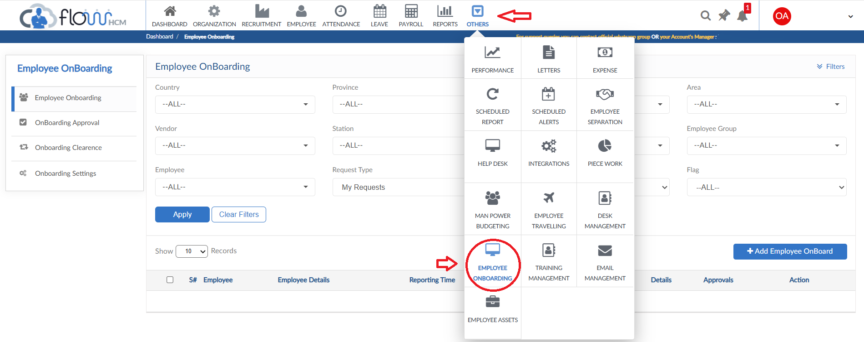
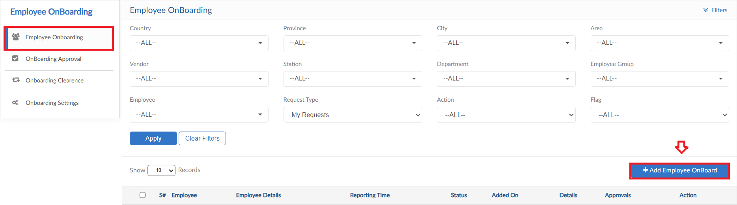
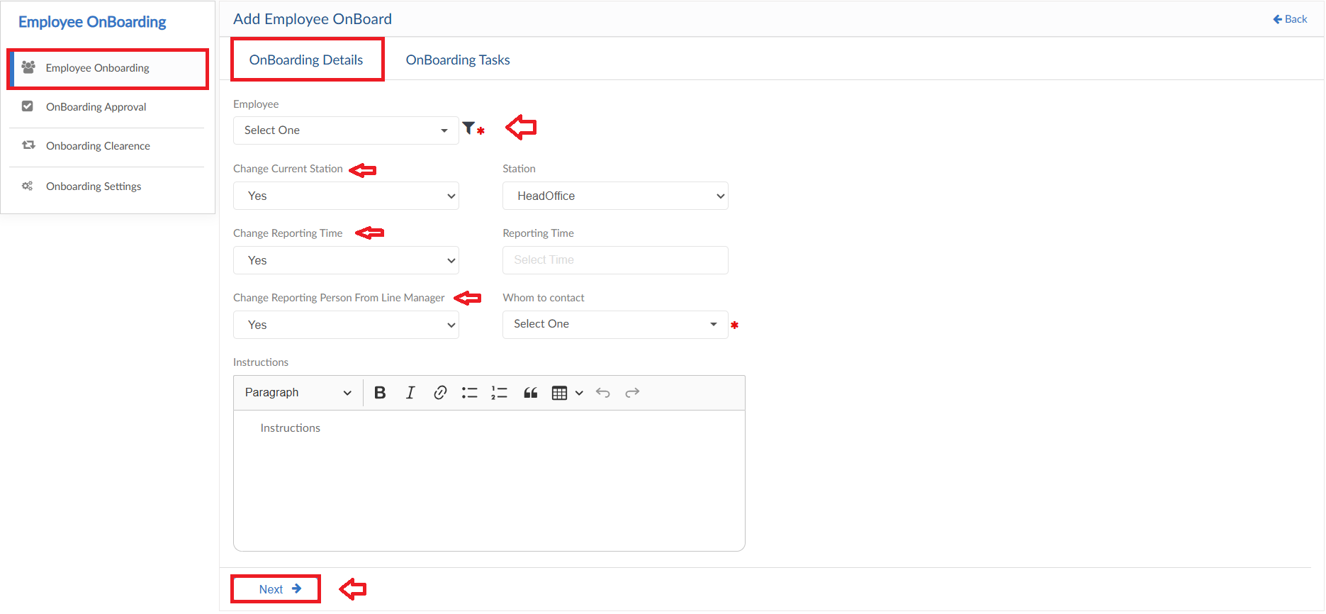
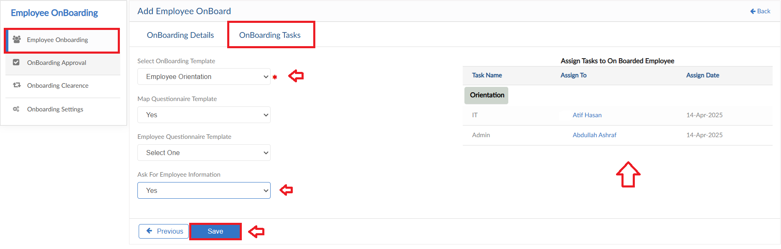

Onboarding Approval

- Move to next tab of Onboarding Approvals
- In this screen all the Employee Onboarding requests will be listed
- Take action against the requests either approve or reject and enter comments
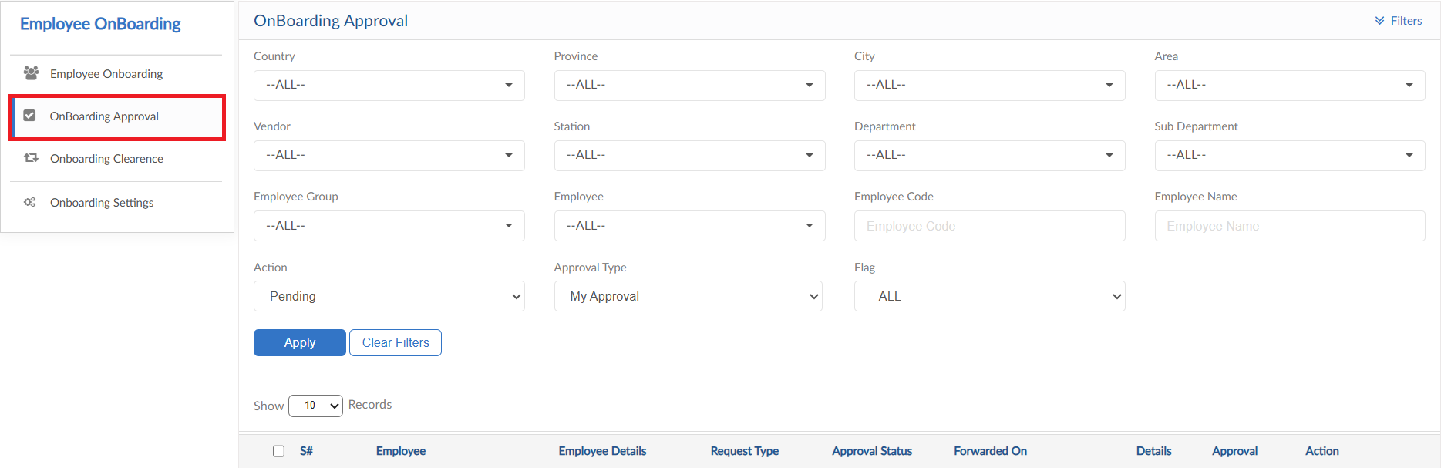

Onboarding Clearance

- Move to next tab of Onboarding Clearance
- Tasks assigned to employees listed in Onboarding Template will shown in this form
- Detail pop up will show the Due date and Description of tasks
- After completion of tasks, request can be marked completed from Action button
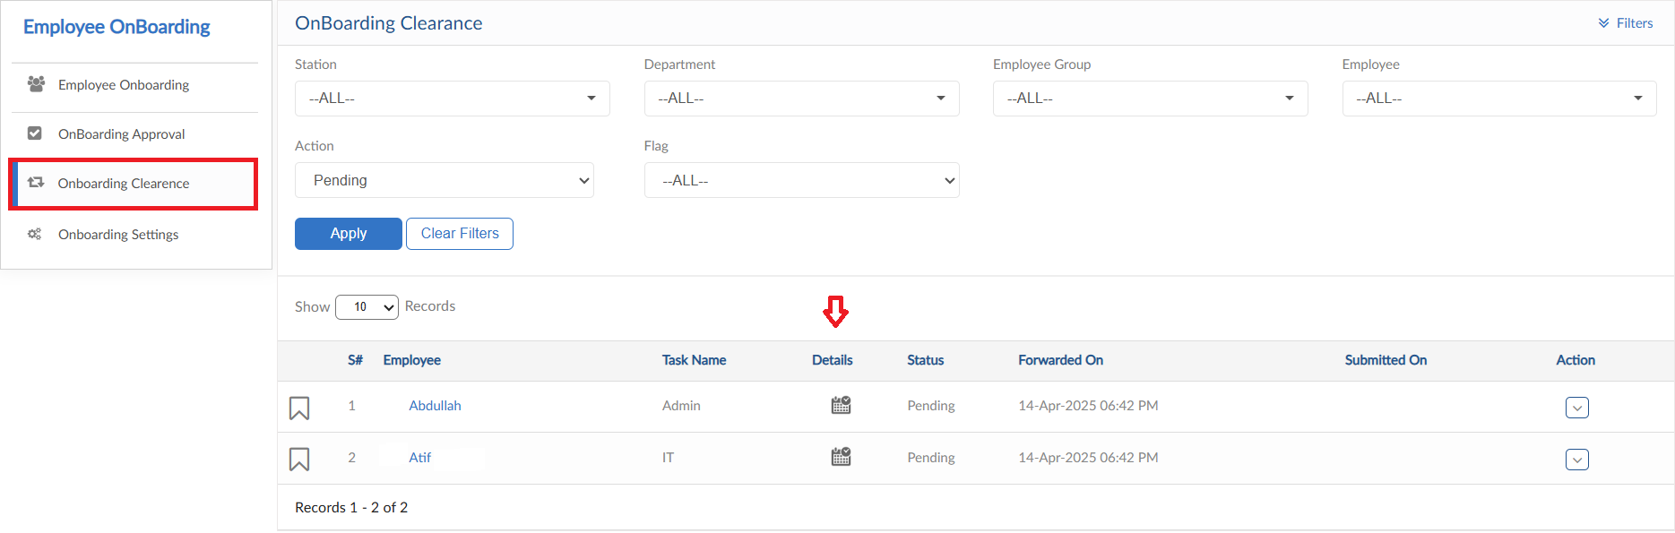
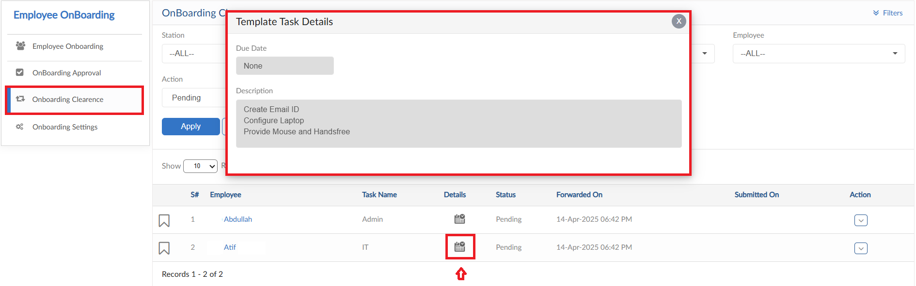

Onboarding Settings

- Onboarding Settings form consists of multiple setup forms
- Click on Onboarding Settings form
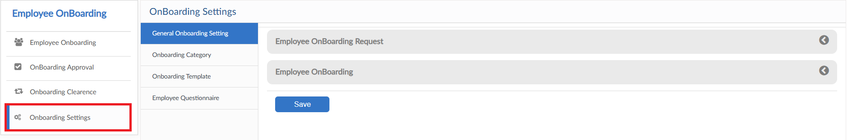

General Onboarding Settings
- Onboarding request approval hierarchy can be maintained here
- Functionality checks are given in this form to make it mandatory or not
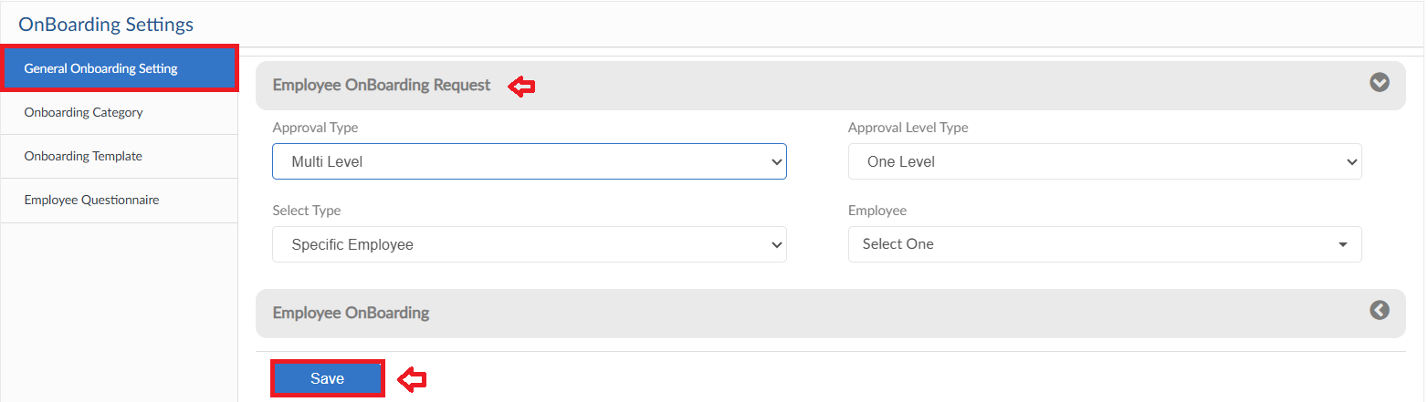
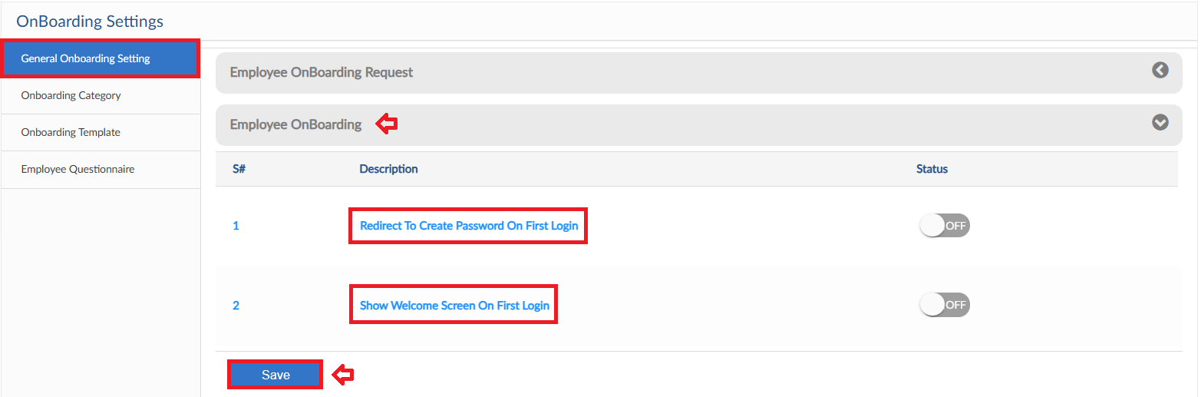

Onboarding Category
- Click on Add New Category button
- Pop up will be visible, enter title of category
- Then click save button, it will be added in the list
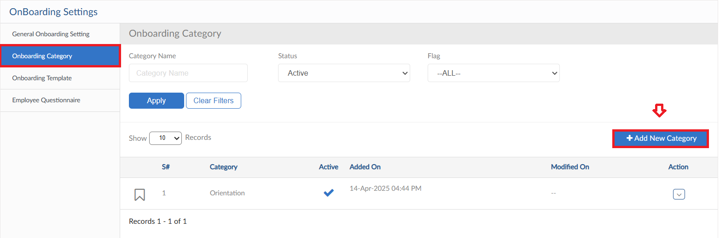
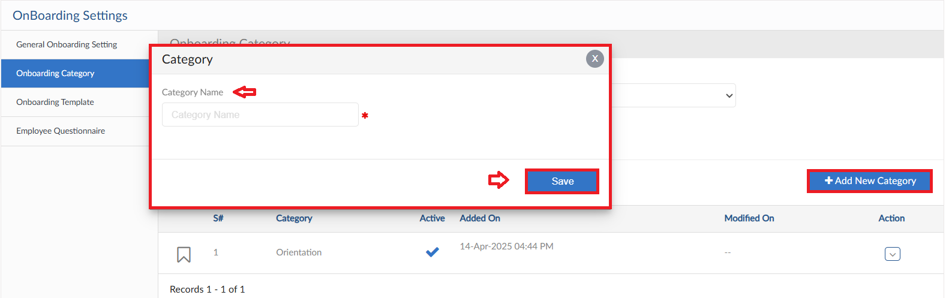

Onboarding Template
- Click on Add Template button
- Enter Template Name and click on Save Template button
- Select category from dropdown and enter task name
- Enter the description and select employee from dropdown to assign task
- Select Due date if required and set notification type for task alert
- If required file can be attached and click Save button
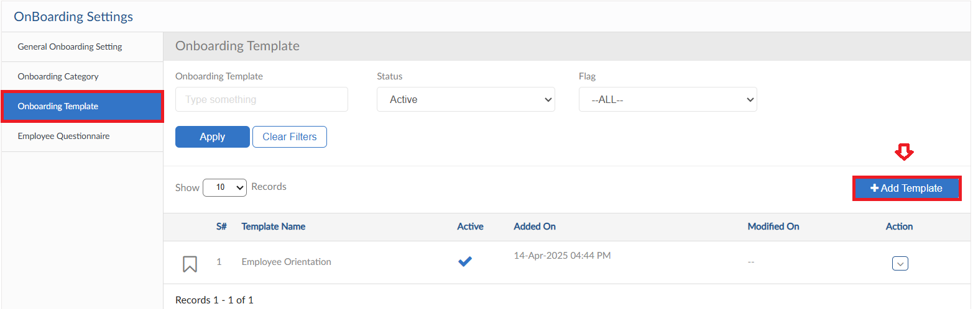
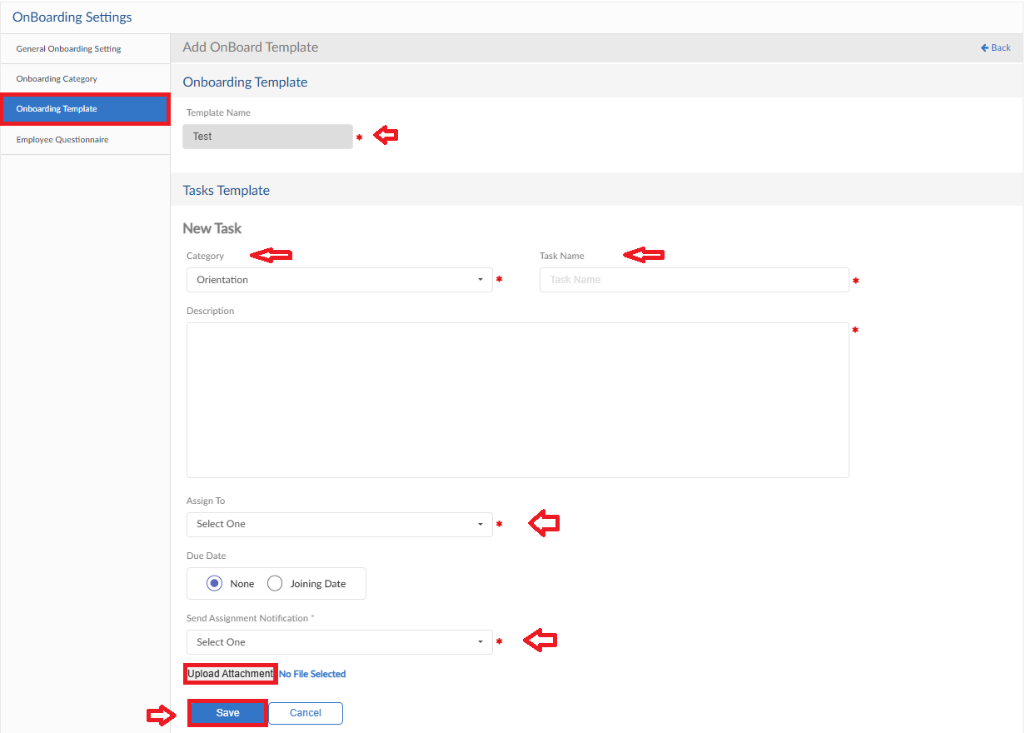

Employee Questionnaire
- Click on Add New Question button
- Enter Questionnaire Title
- Check is given to either send the responses of New joiner to employees or not
- Question can be entered also selected from the Question Bank by dragging the question
- Toggle for every question is given to either make part of the email or not
- Click on Save Question button to save template
